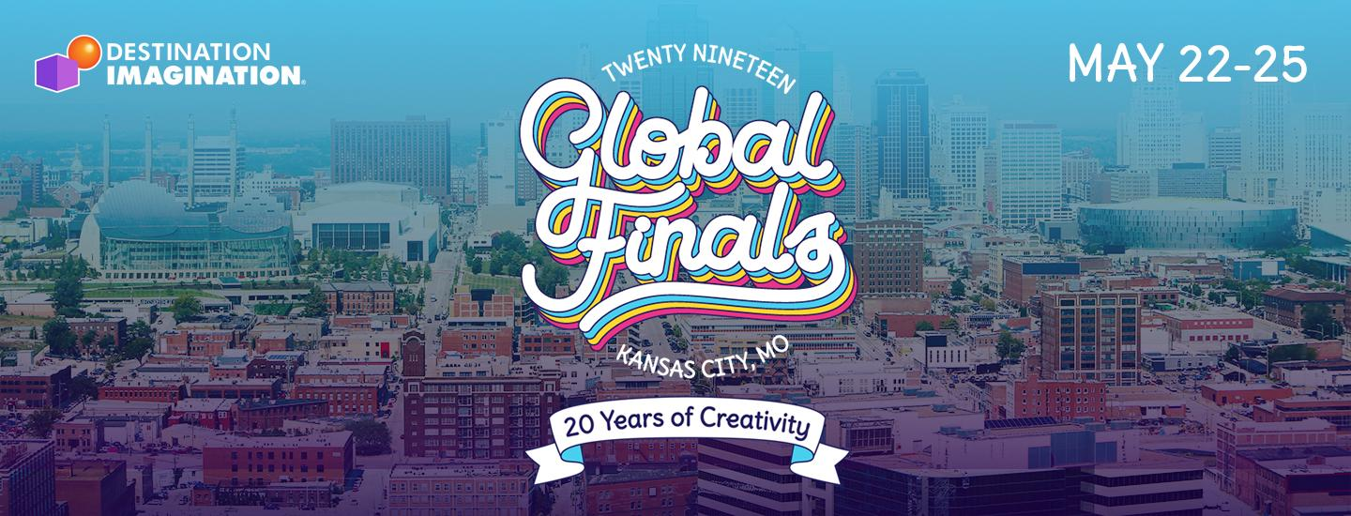
[DATE]
[RECIPIENT’S NAME]
[RECIPIENT’S BUSINESS ADDRESS]
Dear [RECIPIENT’S NAME],
We are [TEAM NAME] from [CITY/STATE] and we participate in Destination Imagination—an educational program that helps us learn valuable skills like creative and critical thinking, problem solving and teamwork through different STEAM-based (science, technology, engineering, arts and mathematics) Challenges.

We are a team of [GRADE LEVEL - i.e., fifth-graders] from [SCHOOL NAME] and this year, our team competed in the [CHALLENGE TYPE - i.e., Scientific Challenge]. We are excited to be one of the top-scoring Destination Imagination teams in our state and to have the opportunity to present our Challenge solution at Global Finals—an international academic competition where we will compete against teams in our Challenge from around the globe.

This year, Global Finals will take place in Kansas City, Missouri. Teams that earn the opportunity to attend Global Finals are responsible for their own fundraising to cover their costs. Because getting to the competition is expensive, our team would welcome the opportunity to partner with [BUSINESS] in support of our Global Finals fundraising efforts.
[EDITABLE FIELD FOR TEAM TO DESCRIBE FUNDRAISING ACTIVITIES/EFFORTS]
We would greatly appreciate the opportunity to partner with you and look forward to speaking with you more about our journey this year.
Best-
[NAME]
[EMAIL ADDRESS]
[PHONE NUMBER]

